# Phase 5: PG FSD Testing in a DevOps Lifecycle

## Assignment - 1: Deploying a project in Amazon EC2

The following are the steps that are involved in the assignment -

1. Create EC2 Instance on AWS
2. Connect to EC2 Instance using SSH
3. Cloning the Repo. on EC2
4. Building the App. Image using Docker
5. Running the Image using Docker
6. Access the Application on Browser using public IPv4 address

### Creating EC2 Instance on AWS

1. Launch AWS Console from the LMS Portal

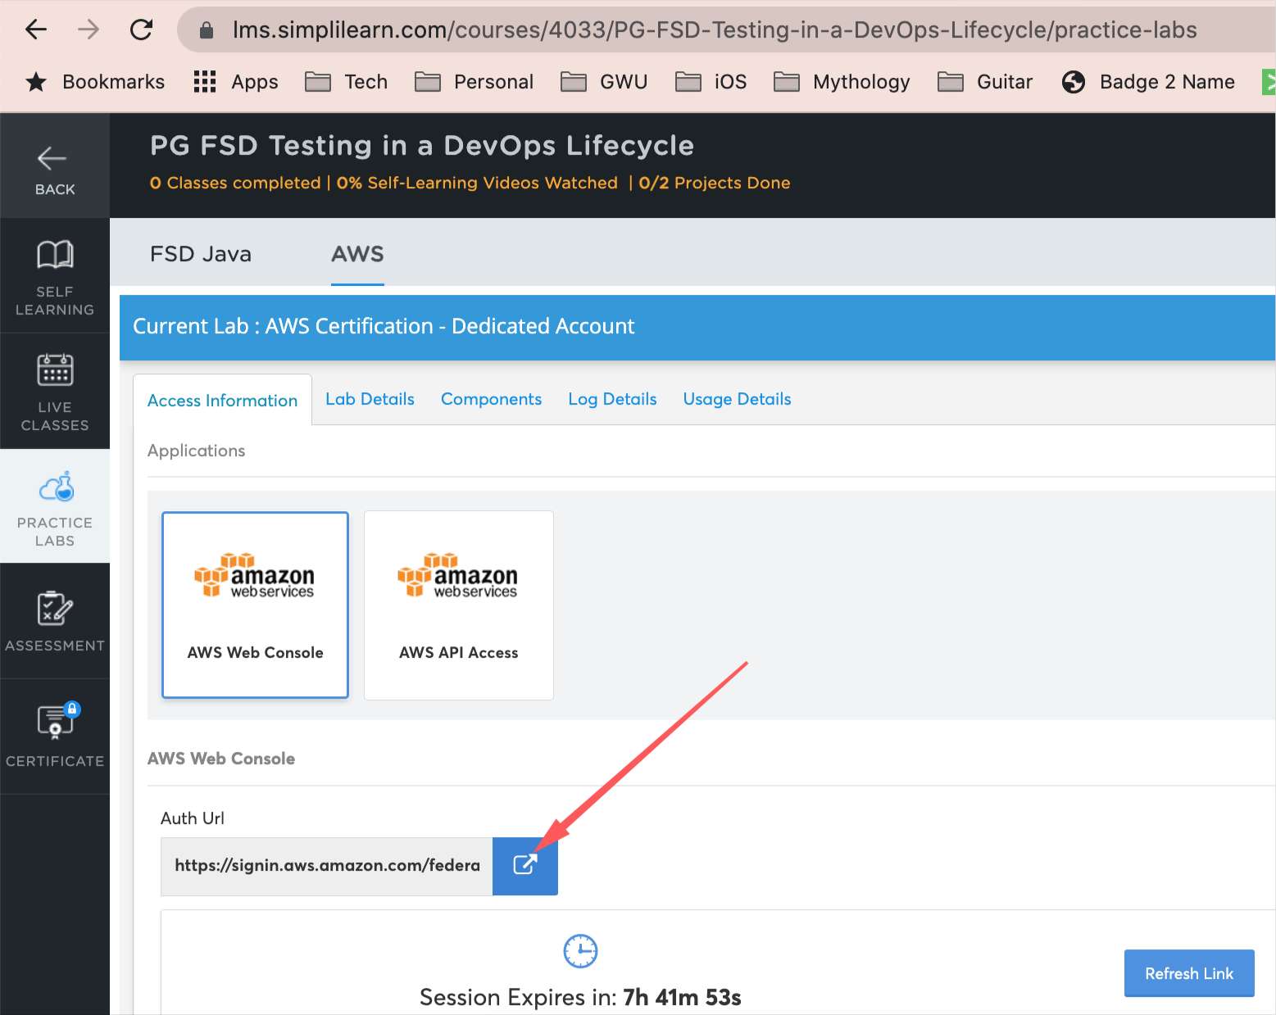

1. AWS Management Console - landing page

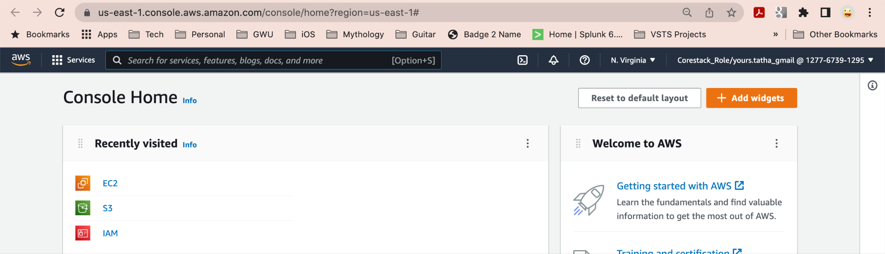

1. Click EC2 or search EC2 from the “Search Bar” on top

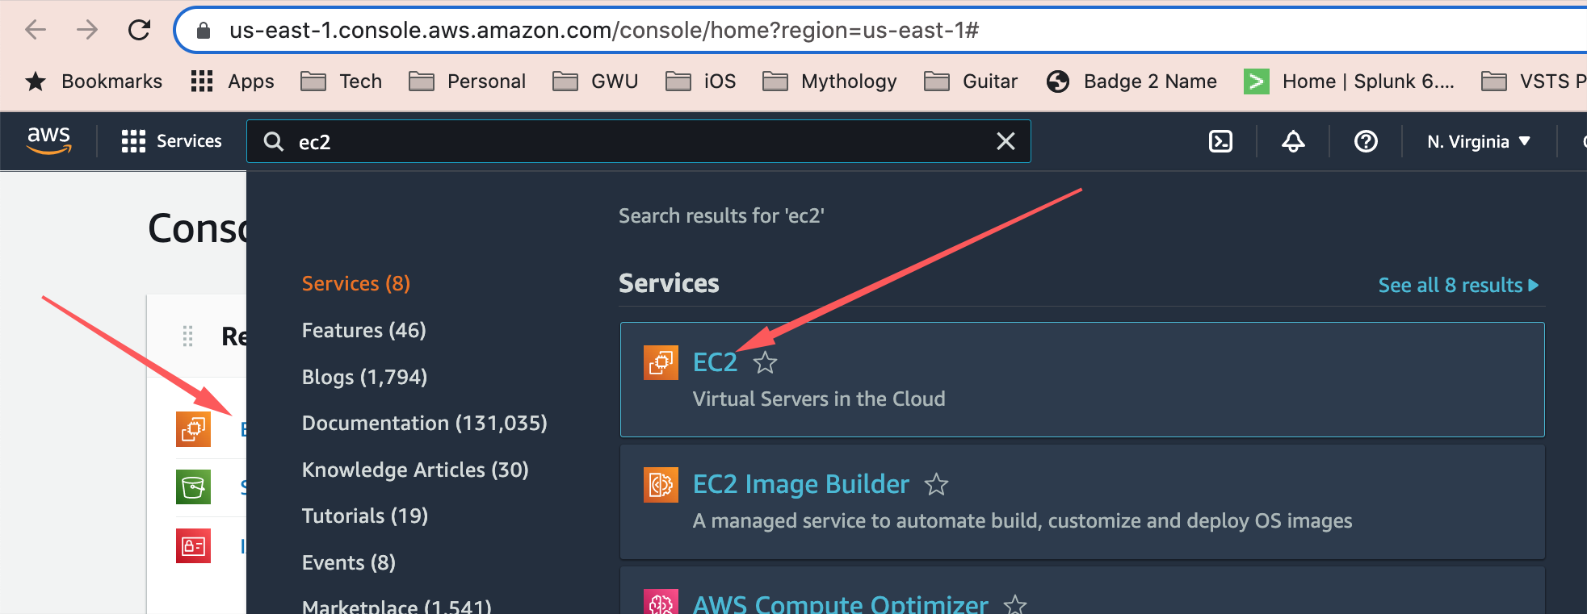

1. Click on “Instances”

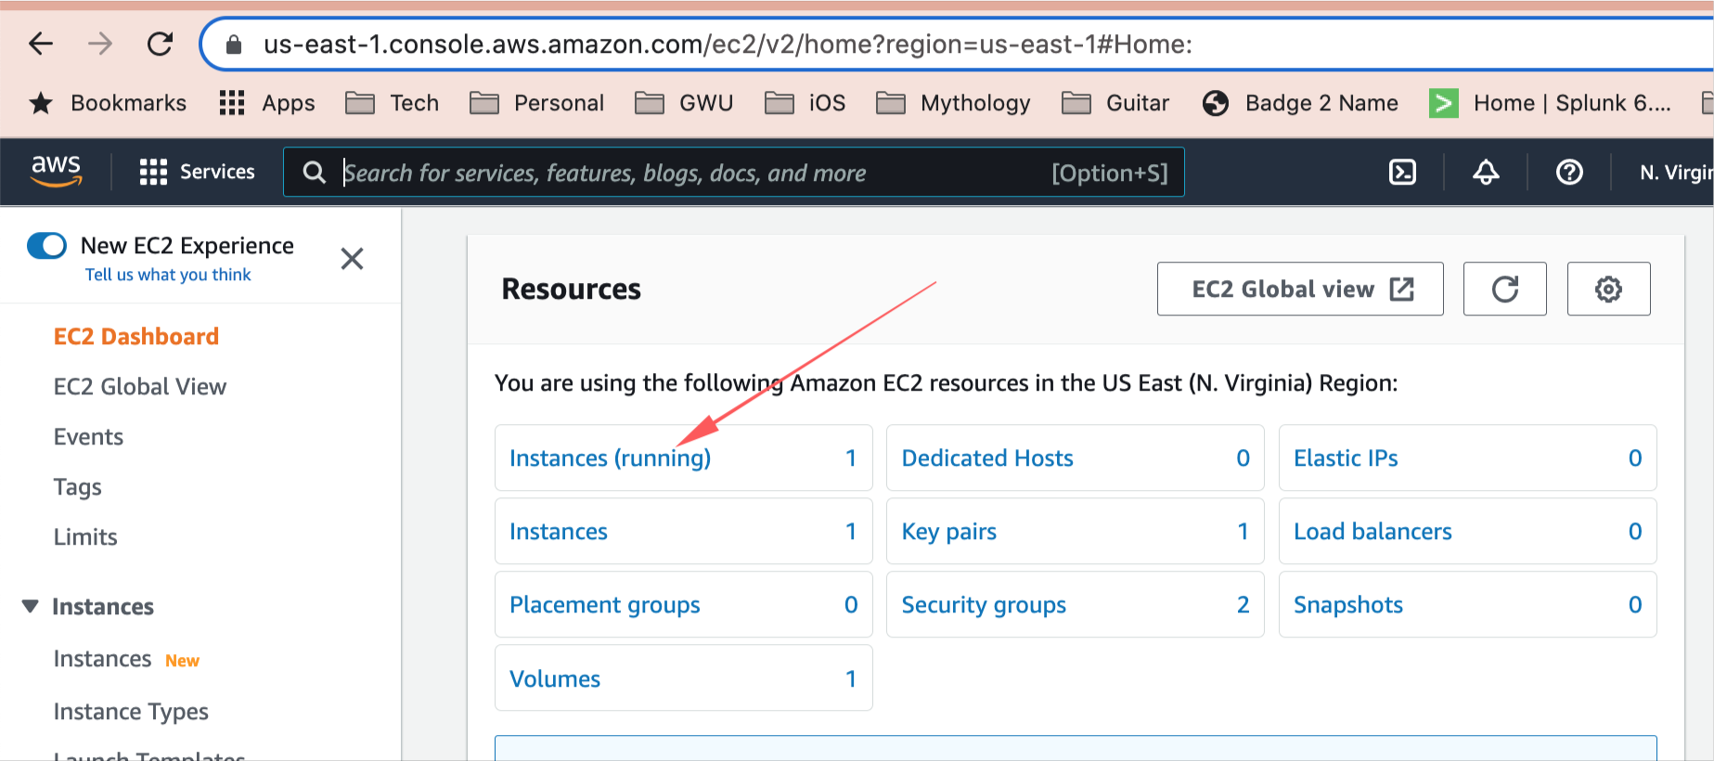

NOTE: We will be creating a New Instance as a part of this exercise

1. Click on “Launch Instance”

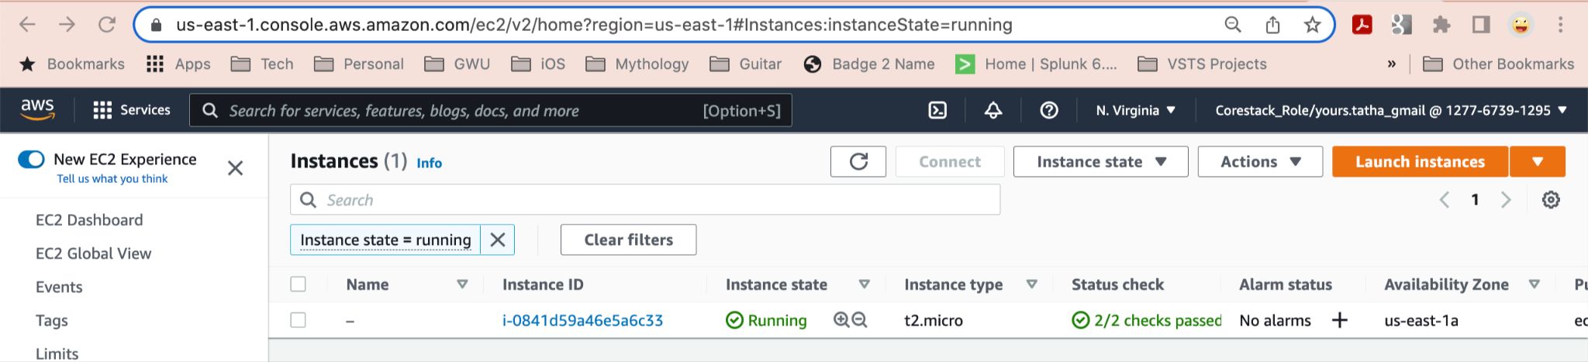

This will let us create a new EC2 Instance

1. EC2 Instance Creation
   1. AMI Selection

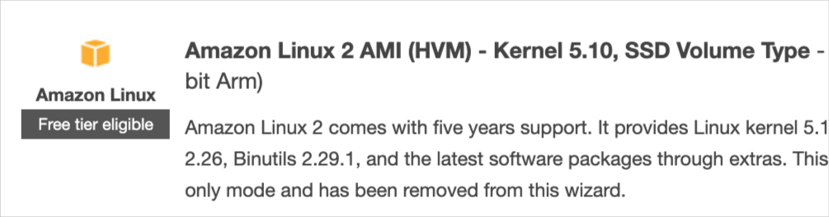

* 1. Instance Type

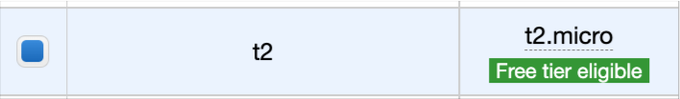

* 1. Configure Instance Details - leave defaults

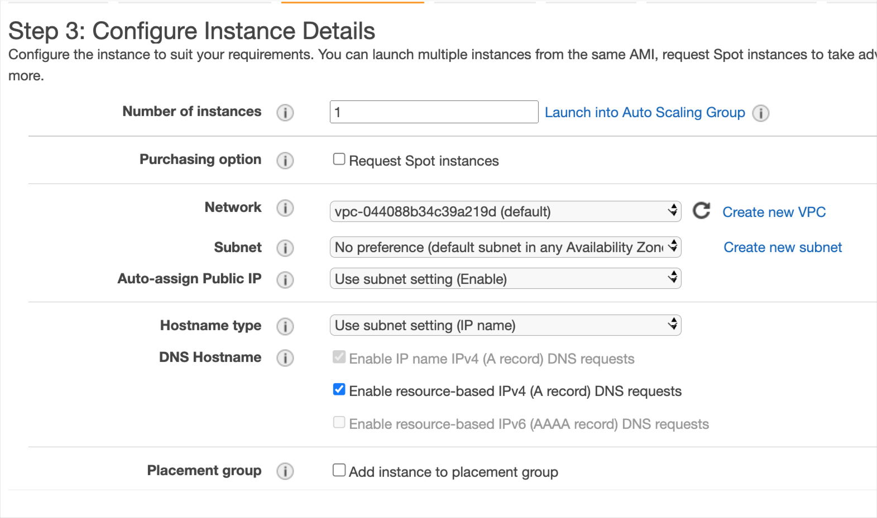

* 1. Add Storage - use defaults

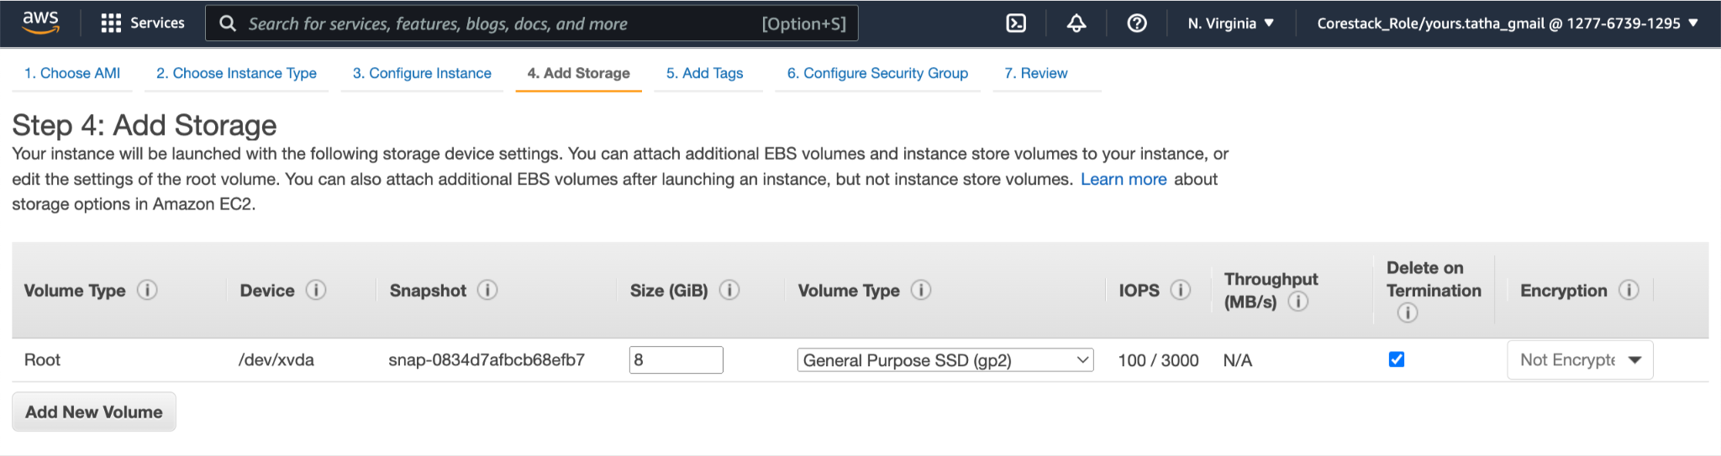

* 1. Add Tags - I added one for testing; can be left blank

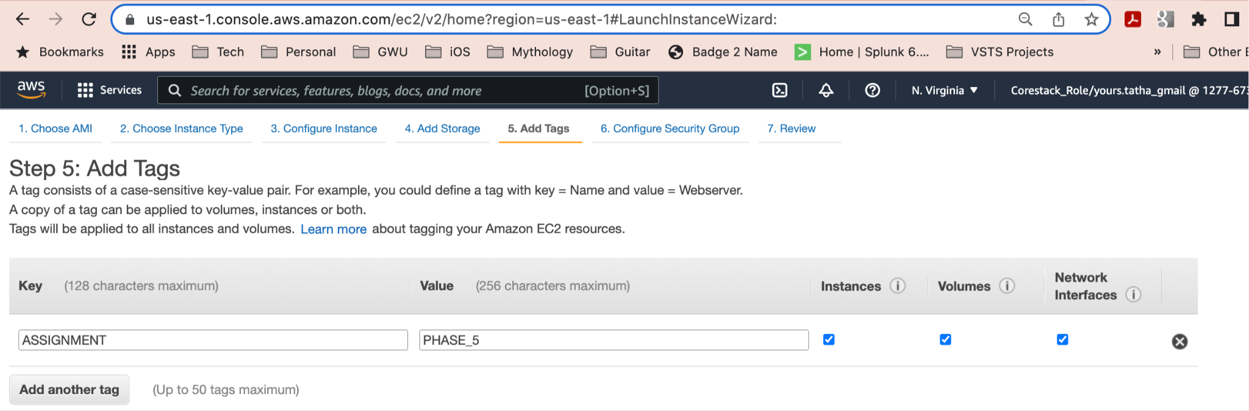

* 1. Security Group - leave defaults

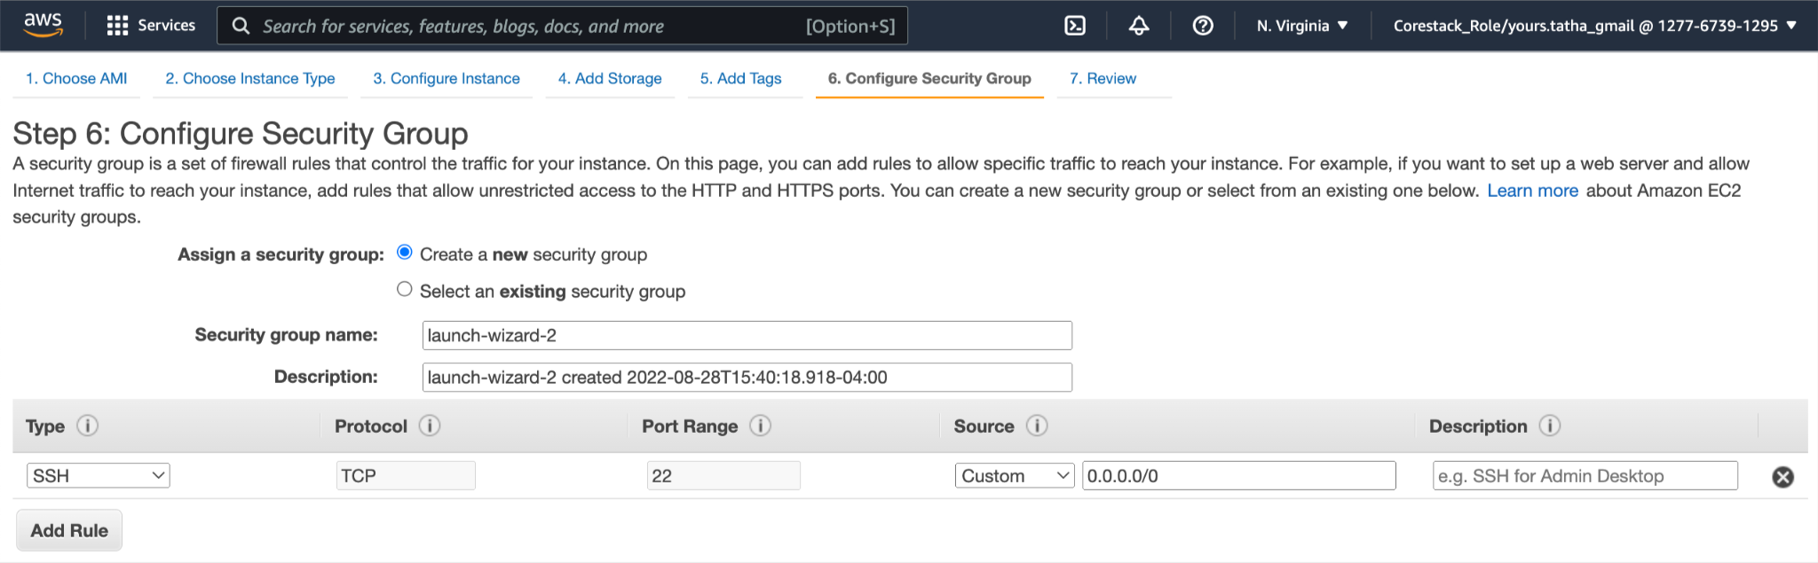

* 1. Review and Launch - review choices and click “Launch” (bottom right)
  2. At this point, a new RSA Key will need to be created. This will enable us to connect to the EC2 Instance from the Command Line
     1. Choose - “Create a new key pair”

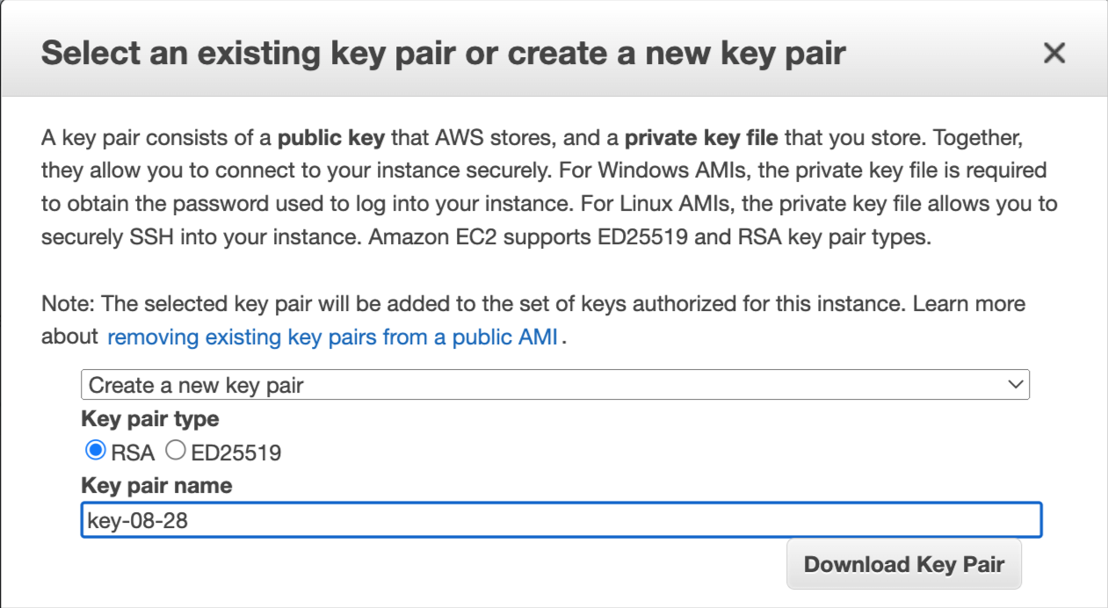

* + 1. Enter a key pair name
    2. Download the Key Pair and keep it in a folder. We will be using it later
    3. Click “Launch Instances”
  1. A message like the one below should be displayed

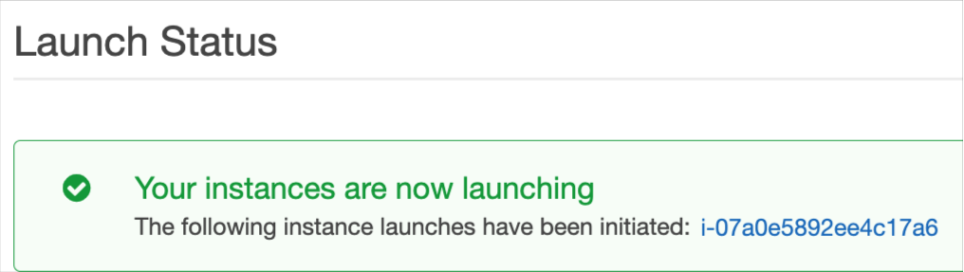

* 1. Navigate [AWS Management Console > Instances]

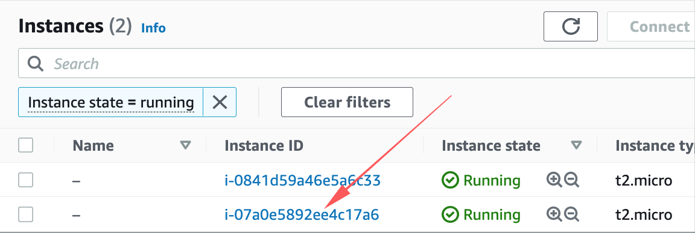

1. Connecting to the AWS EC2 Instance from Terminal/Command Line
   1. Open Terminal (or cmd line) at the location where the Key Pair was saved in the earlier step

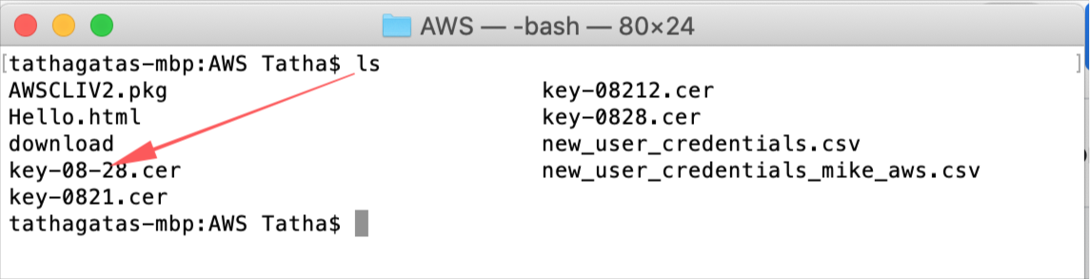

* 1. We need to change permissions on the Certificate file

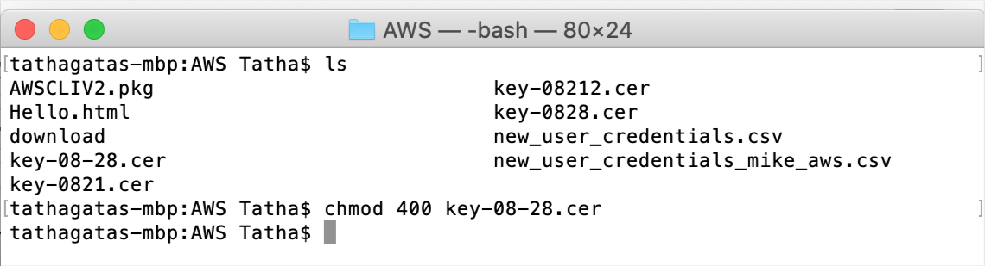

* 1. Select the Instance in the AWS Console and click on ‘Connect’

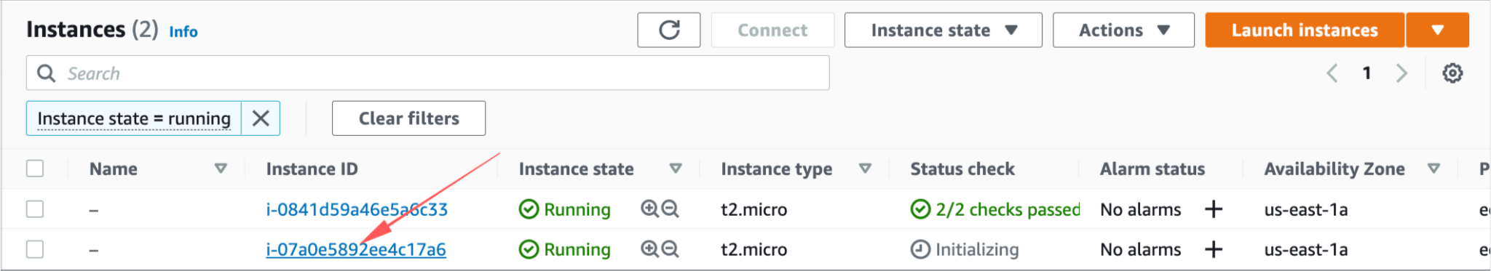

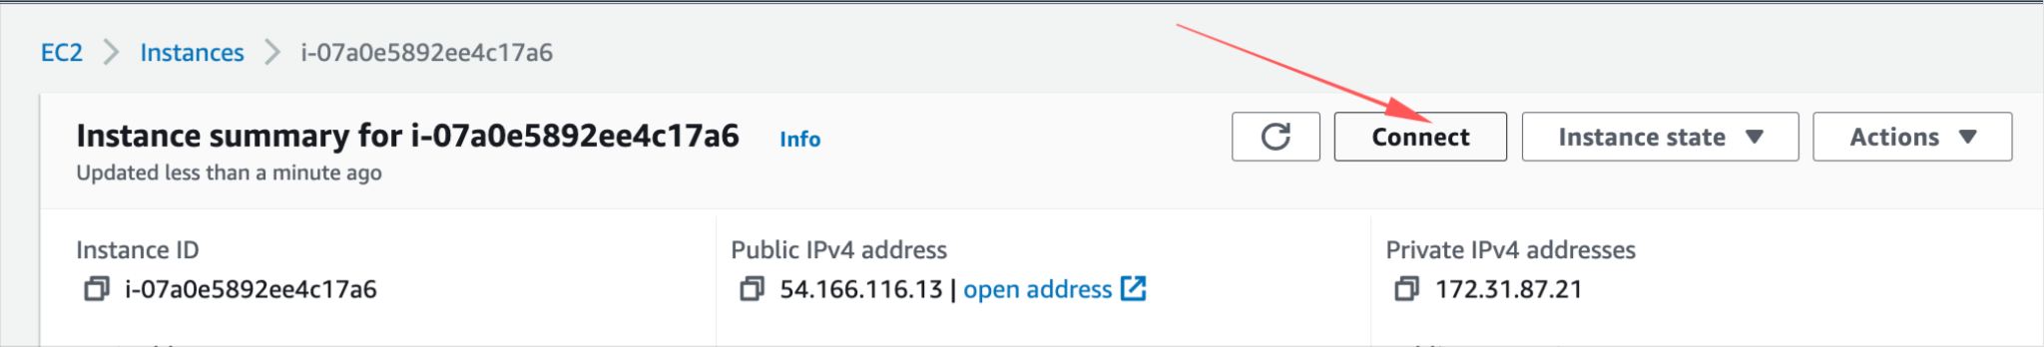

* 1. Copy the example statement

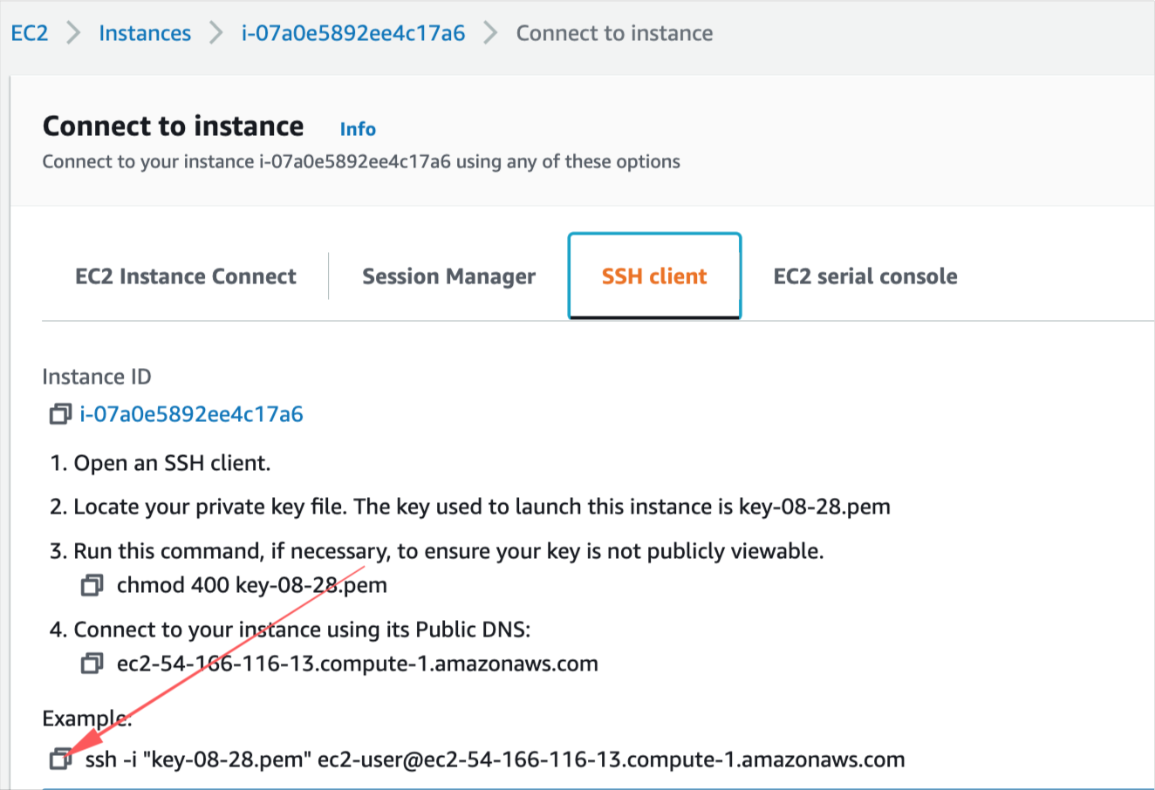

* 1. Enter the following command in the terminal (change .pem to .cer)

ssh -i "key-08-28.cer" ec2-user@ec2-54-166-116-13.compute-1.amazonaws.com

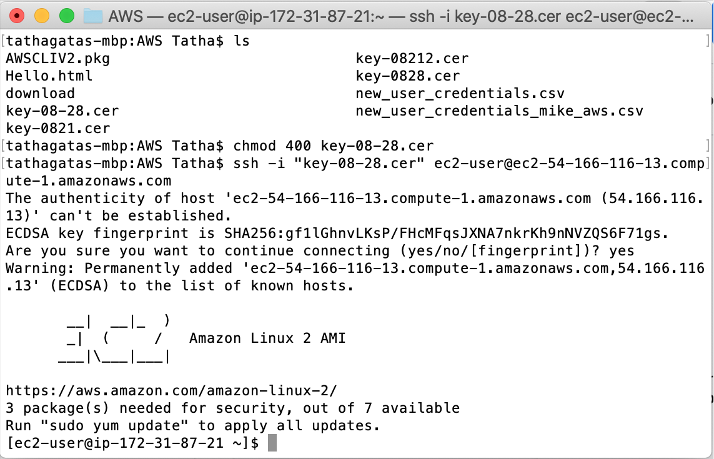

1. Install/Update Softwares
   1. Update the packages on your instance

sudo yum update -y

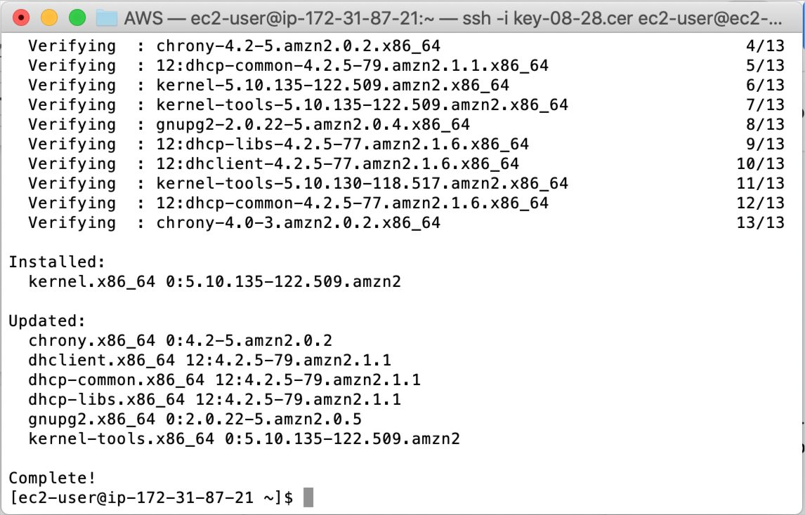

* 1. Install git

sudo yum install git -y

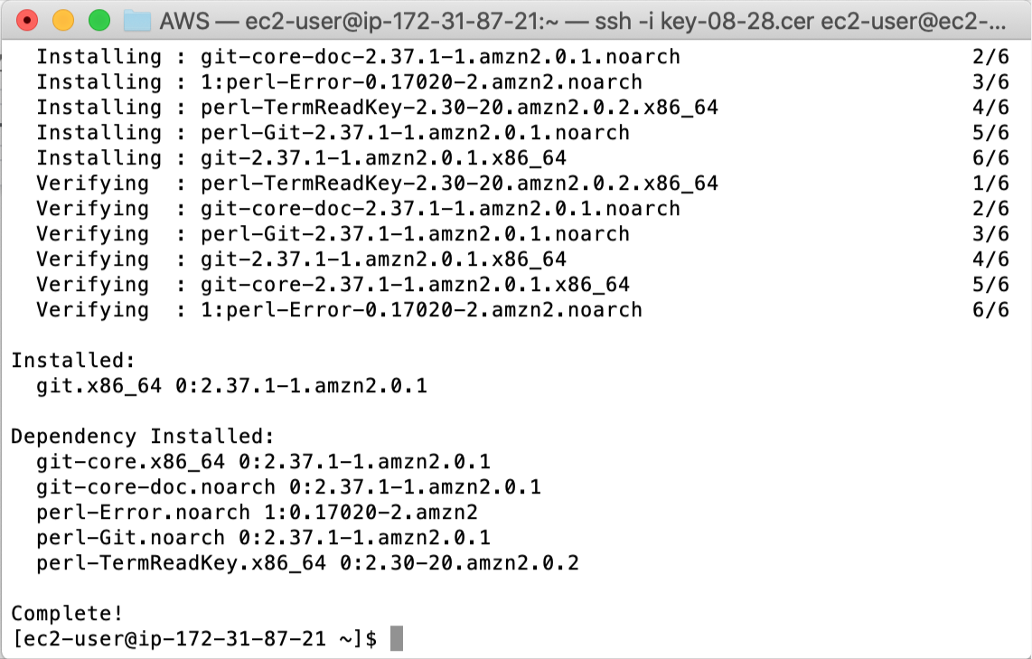

* 1. Install Docker

sudo yum install docker -y

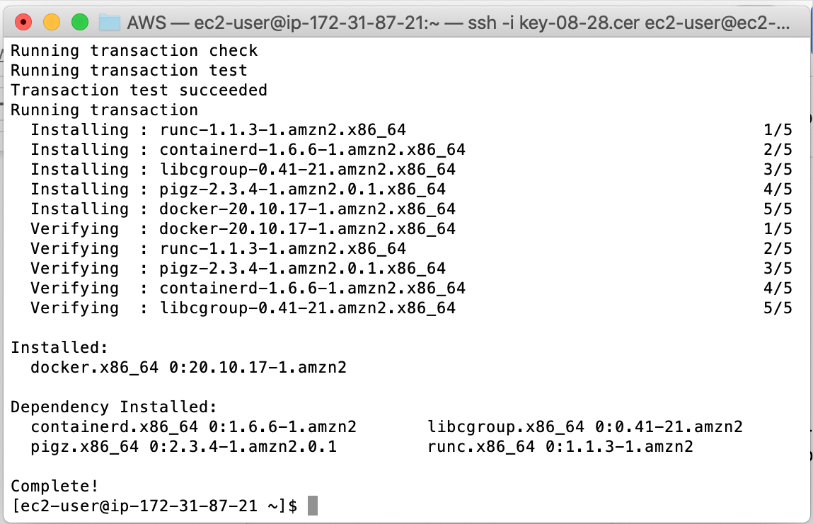

* 1. Start Docker Service

sudo service docker start

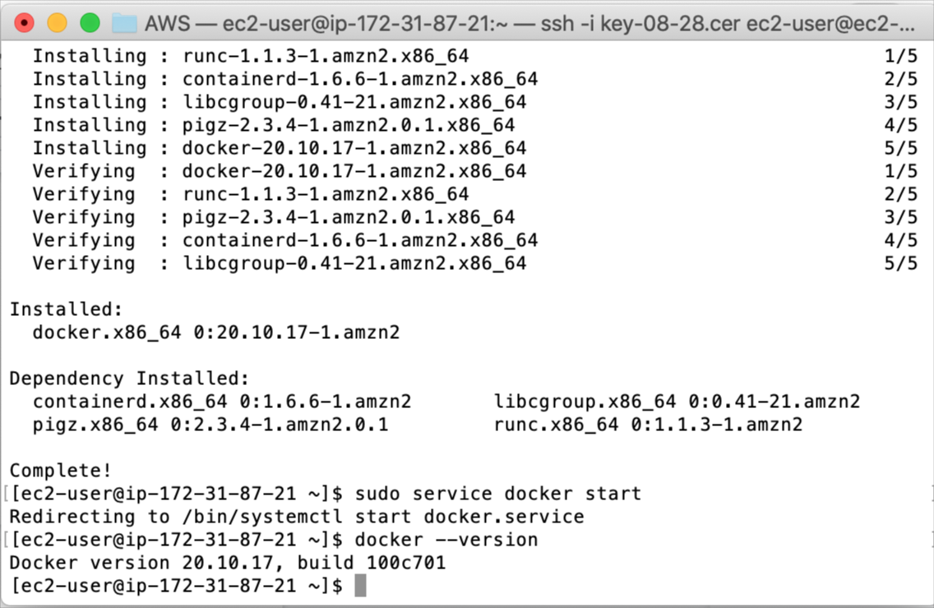

1. Download from GitHub
   1. Create a new folder; Set Remote; Pull

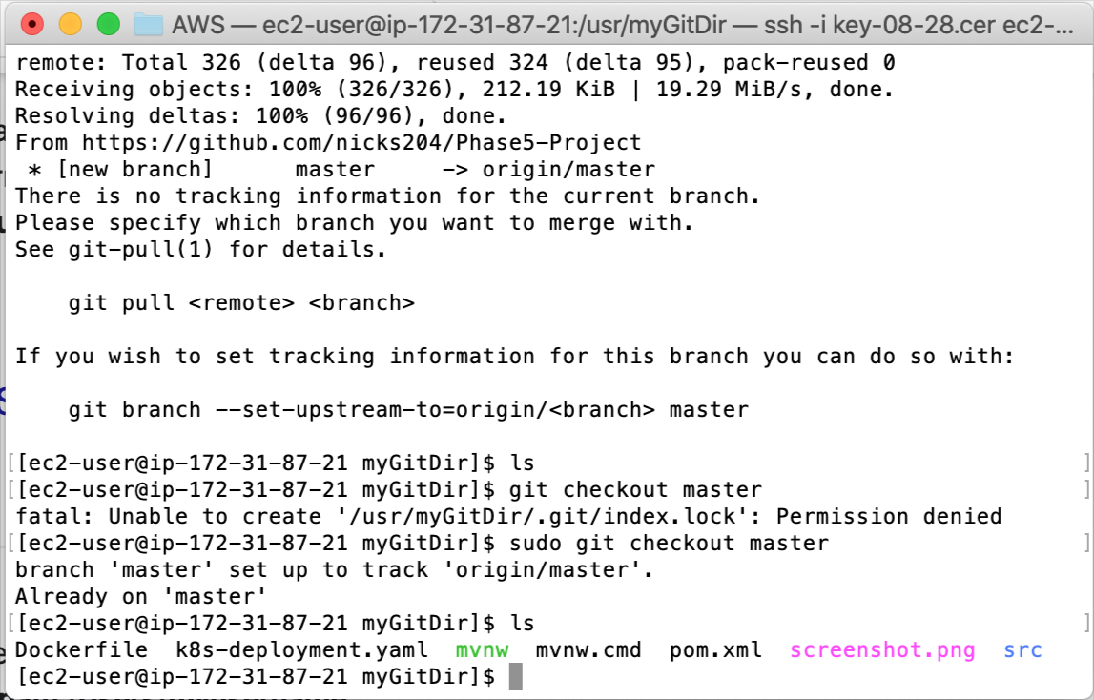

At the end of this step, artifacts would be downloaded from -

<https://github.com/nicks204/Phase5-Project> to the EC2 Machine

2. Run Docker Build

docker build -t projectimage .

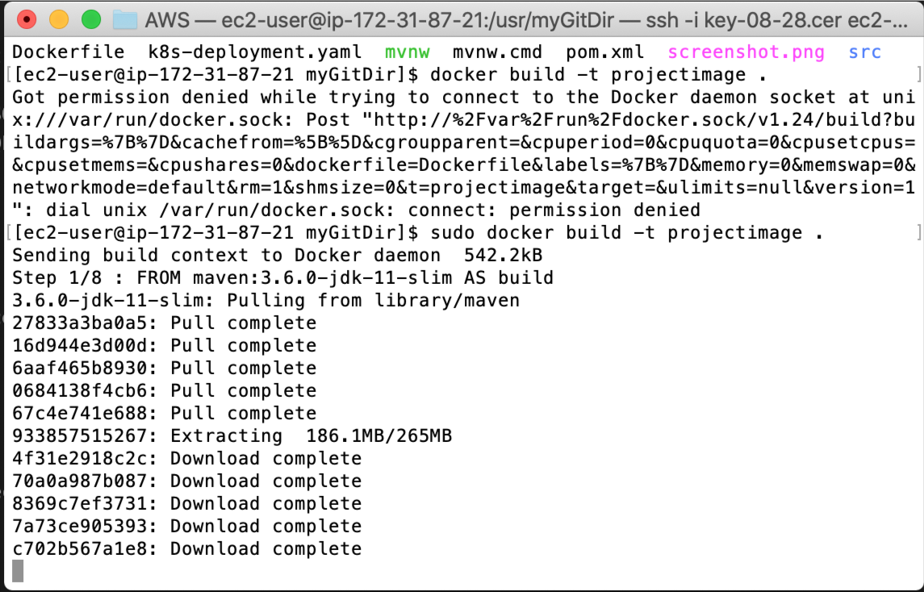

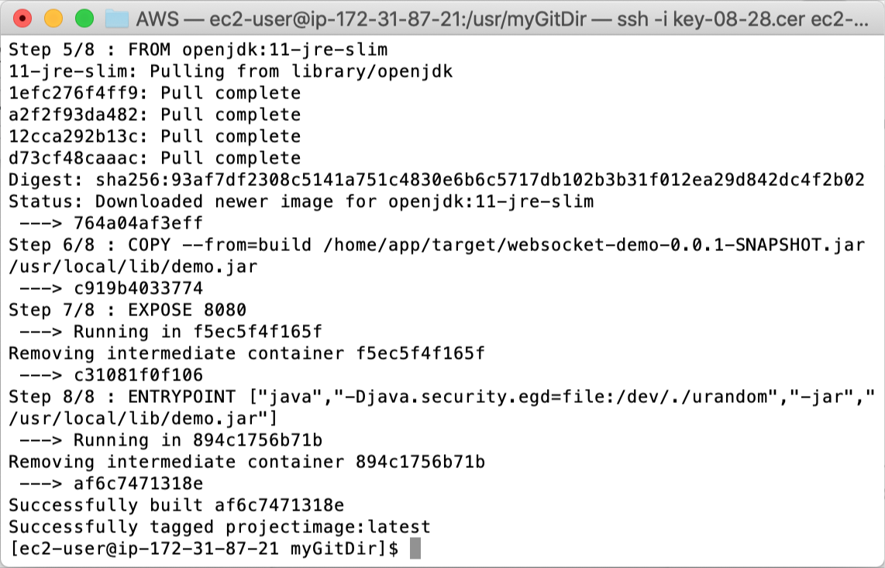

1. Start Docker Instance on Port 8080

docker run -d --name projectcontainer -p 8080:8080 projectimage

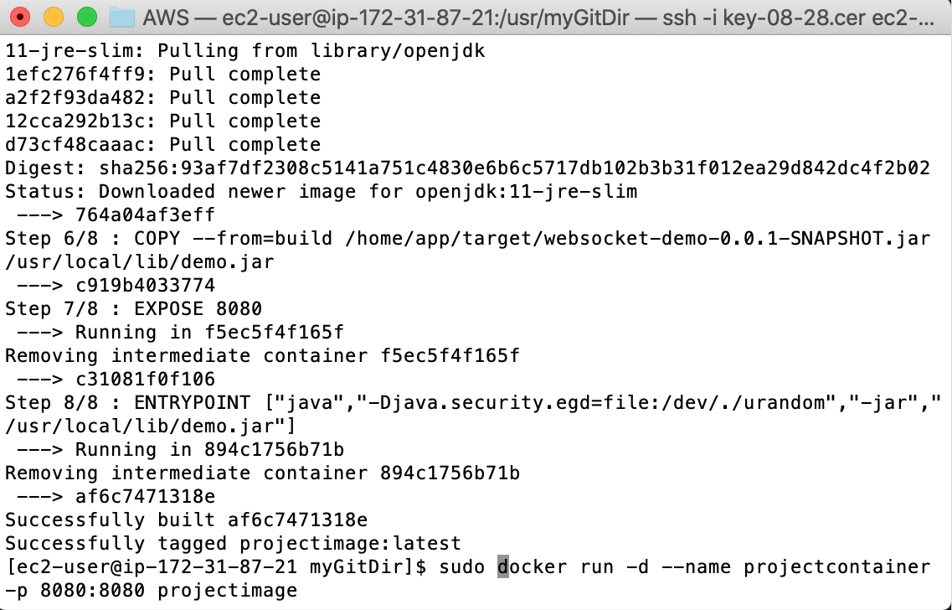

1. Assign permissions
   1. Go to the security settings for the EC2 Instance

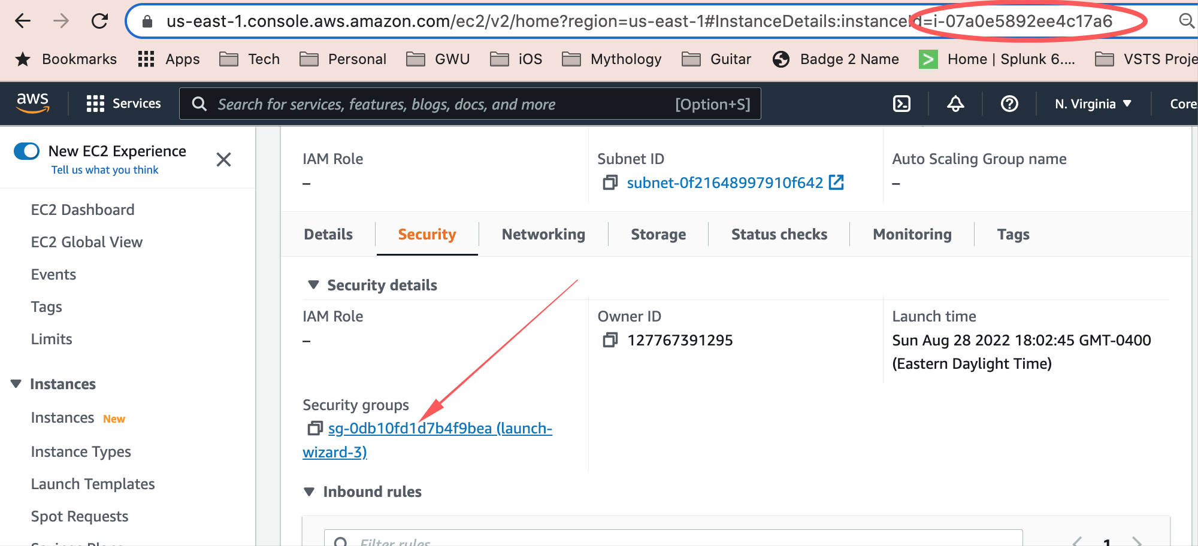

* 1. Edit Inbound Rules

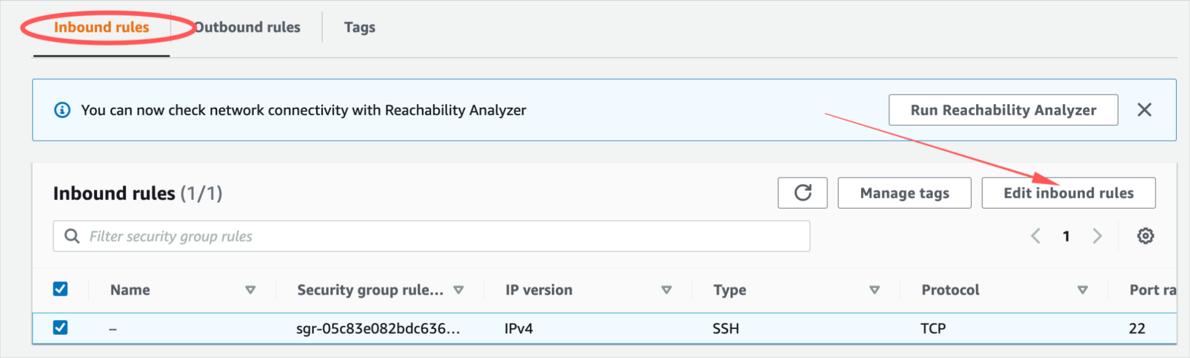

* 1. Add a line for ‘All Traffic’, ‘Anywhere IPv4’

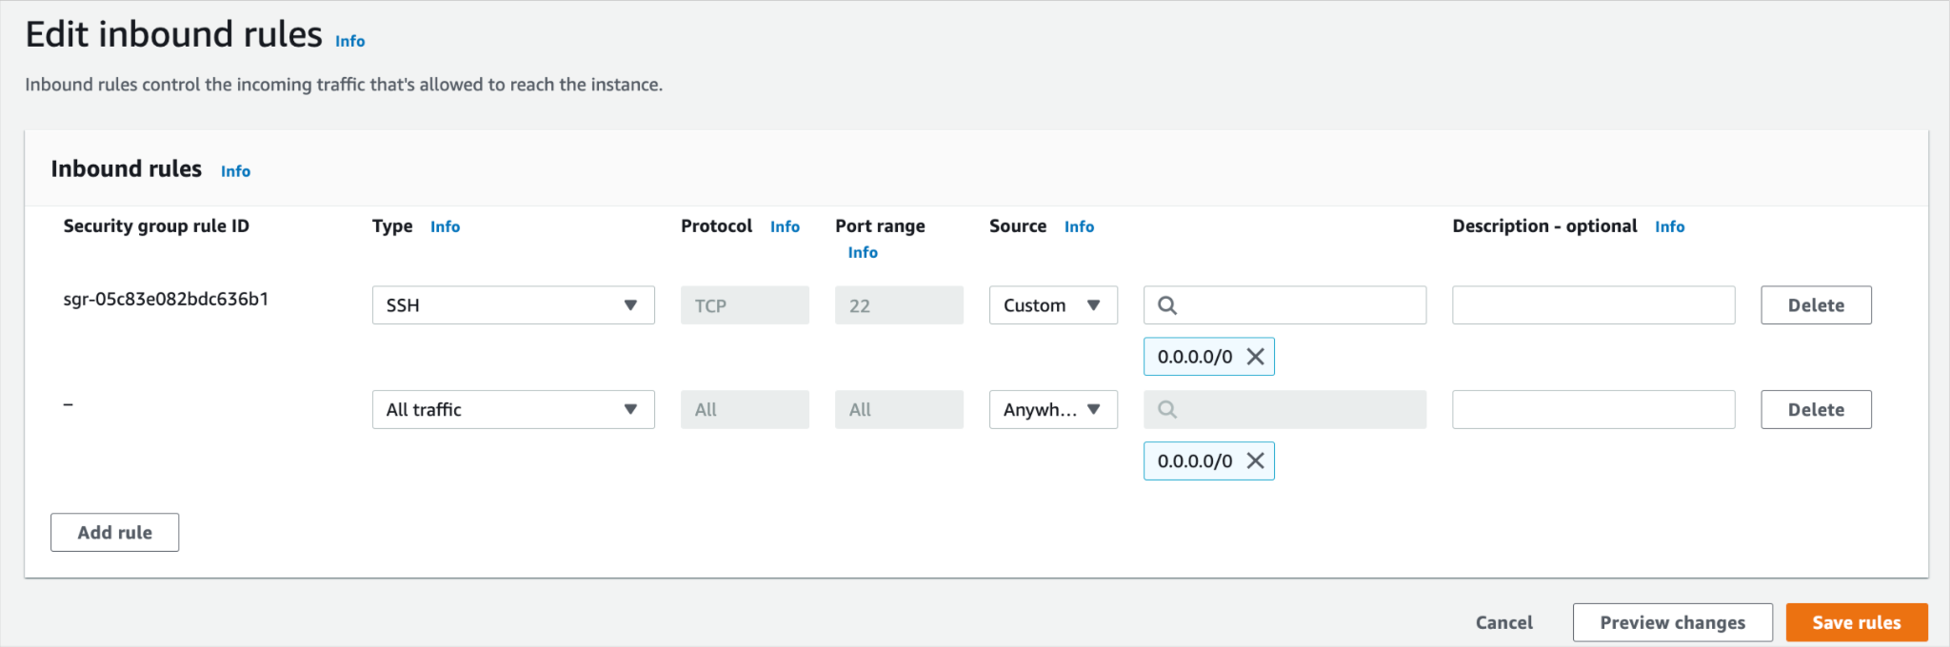

1. Access the Application
   1. Copy the public ip address

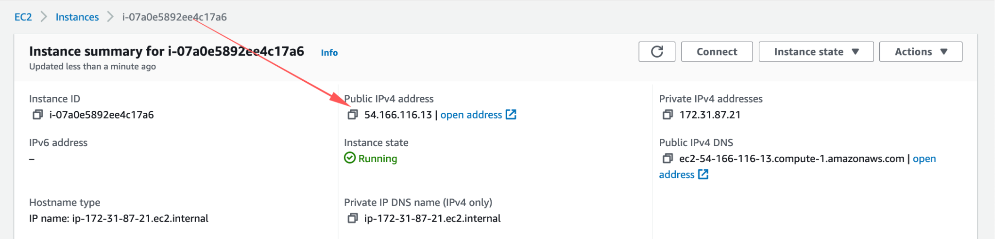

* 1. Access the Application on Port 8080

